Title of abstract (max. 2 lines)
Given Name Family Name of 1st Authorª, Given Name, Family Name of 2nd Authorª, Given Name Family Name of 3rd Author^{b,}*
ªAuthor’s affiliation, City, Zip code, Country
^{b}Author’s affiliation, City, Zip code, Country
*Corresponding author: E-mail address
This is a template for abstract submissions to ISSF-ISHA 2025, Bali, Indonesia. Please use this template to prepare your abstract without changing the formatting. The maximum length of the abstract is one page of A4-sized paper (including figures, equations, and tables), single-sided, with a top margin of 0.98” and side and bottom margins of 0.79”. Use Times New Roman 11 font (or equivalent), single line spacing, with 6 pt space after each paragraph.
Indicate references [1,2] (or [1–3] for more than two citations) by number(s) in square brackets in line with the text. Number the references (numbers in square brackets) in the list in the order in which they appear in the text. An example of the reference style is shown at the bottom of this page. Please carefully follow the format and use 9 pt Times New Roman font.
he submitted abstract will be used for the selection of contributions. Accepted abstracts will be published in the electronic book of abstracts. Preference in the selection of oral and poster presentations will be given to unpublished results, while the keynotes preferably summarize a longer, coherent research or development.
In the abstract, please provide a brief description of the motivation for your work, the research methodology, and emphasize the most relevant results. A graphical illustration is also welcome.
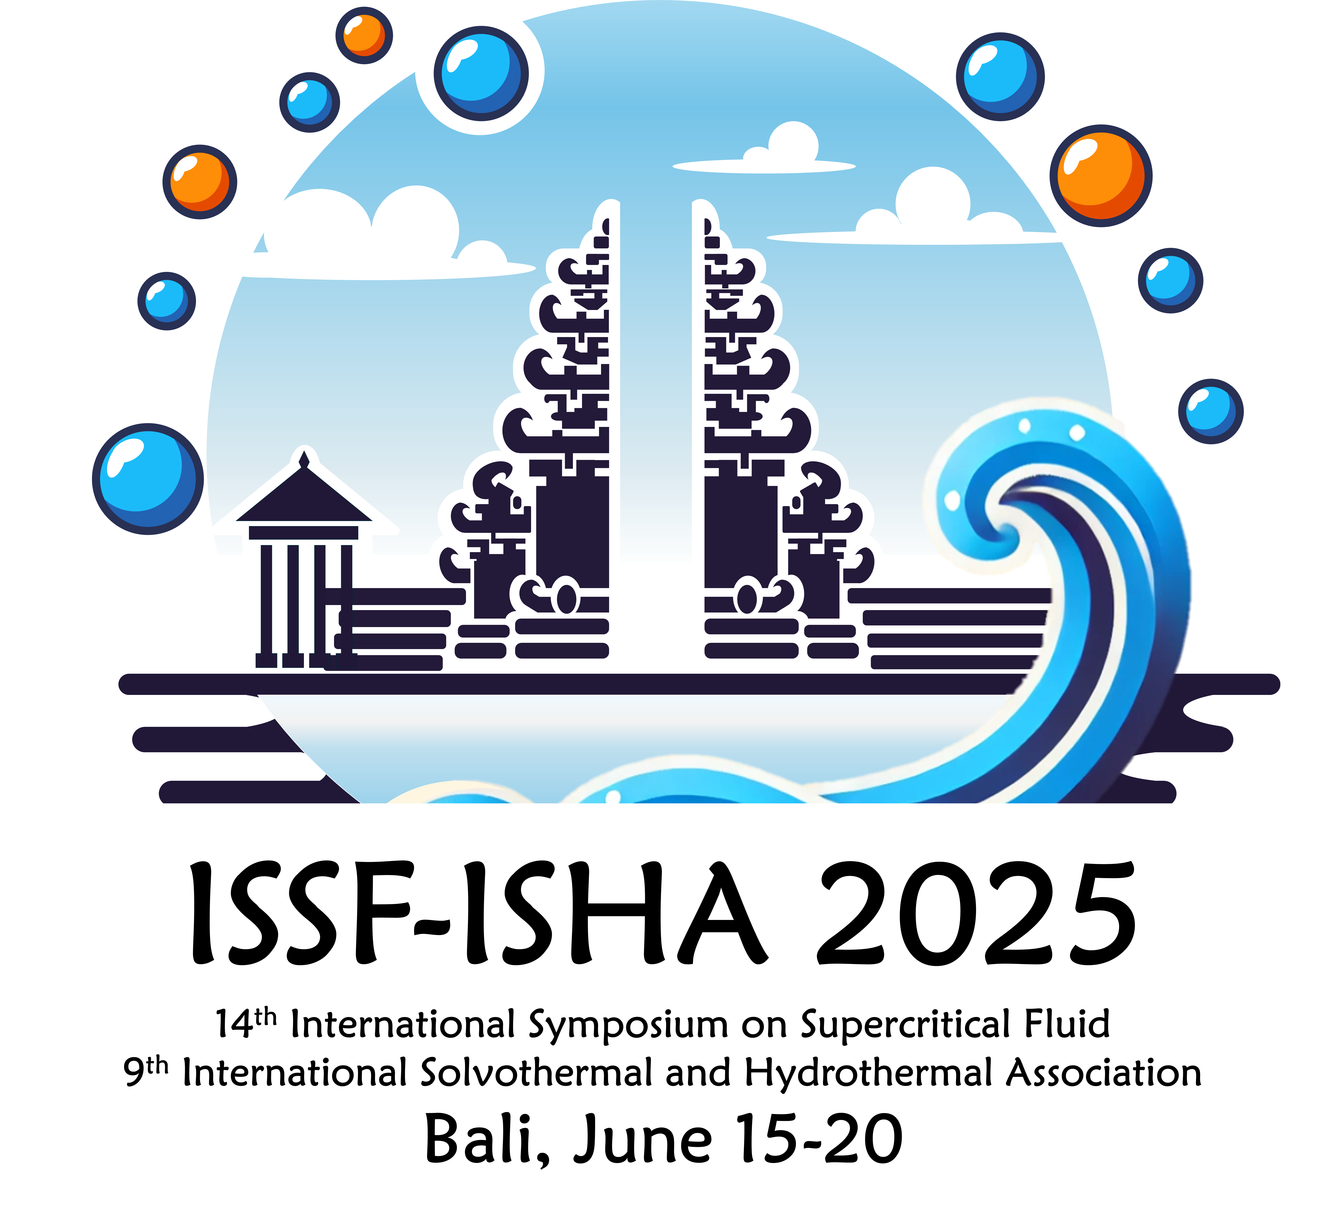
Figure 1. Caption of figure (9 pt).
Captions for tables and figures should be in 9 pt with 6 pt space above and below. You can include figures wrapped in the text or in an empty line with centering. Equations should be included without numbering, with 6 pt space above and below. Explain all applied notations, e.g.,
$$c_{p}-c_{v}=T v \frac{{β_{p}}^{2}}{κ_{T}},$$
where $c_{p}$ and $c_{v}$, $T$, $v$, $β_{p}$ and $κ_{T}$ denote the isobaric and isochoric specific heat capacities, the temperature, the specific volume, the isobaric cubic thermal expansion coefficient and the isobaric compressibility coefficient, respectively.
Conclusions should clearly indicate the main findings and their impact on supercritical fluids science and technology.
Please submit your abstract in a single PDF file. After accepting your contribution, you will receive further information about submitting the source files (Word or LaTeX file and the figures) to ensure that the abstract appears in maximum quality in the electronic abstract book. The maximum size of the PDF file is 10 MB.
References
[1] A.B. Author, C.D. Author, E.F. Author, J. Supercrit. Fluids 2020, 156, 104665
[2] G.H. Author, J. Supercrit. Fluids 2021, 178, 105366.
[3] I.J. Author, J. Supercrit. Fluids 2022, 189, 105699.

