Buxing Han, Editor-in-Chief
Institute of Chemistry, Chinese Academy of Sciences
ORCID: 0000-0003-0440-809X
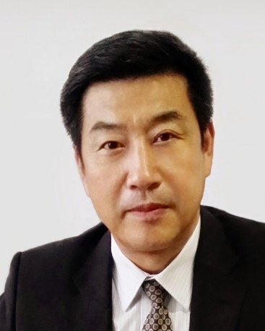
Photo of Buxing Han
CV of Prof. Buxing Han
Buxing Han, Professor at Institute of Chemistry, Chinese Academy of Sciences (CAS); Academician of Chinese Academy of Sciences; Fellow of The World Academy of Sciences (TWAS) for the Advancement of Science in Developing Countries; Fellow of Royal Society of Chemistry. Director of Carbon Neutral Chemistry, Institute of Chemistry, CAS; Director of Shanghai Key Laboratory of Green Chemistry and Chemical Processes.
His research interests include physicochemical properties of green solvent systems and application of green solvents in green chemistry, especially on transformation of CO₂, biomass, and organic wastes into valuable chemicals and fuels. He has published more than 1000 papers in peer-reviewed scientific journals, such as Science, Nat. Chem. Nat Catal., Nat. Synth. He has also published more than 100 patents, and has presented more than 300 plenary or invited lectures at different conferences. He has received a number of awards, such as 2nd-Class Award of Chinese Government for Development of Natural Science, Outstanding Science and Technology Achievement Prize of the Chinese Academy of Sciences.
He is the Chairman of Interdivisional Committee on Green Chemistry for Sustainable Development, International Union of Pure and Applied Chemistry (IUPAC), Chief Scientist of China Innovation Think Tank; Chairman of Green Chemistry Division, Chinese Chemical Society; President of Beijing Energy and Environment Society; He is an Editor-in-Chiefs of The Innovation, Green Energy and Environment, Carbon & Hydrogen; Associate Editors of Chinese Sci. Bulletin, Acta Physico-Chimica Sinica, Chemical Journal of Chinese Universities, and is serving more than 10 other peer-reviewed scientific journals as Editorial Board Member or Advisory Board Member.

